PRDA-04 CAPSTONE PROJECT
Job Market Analysis
Analyzing U.S. Data Science Job Postings — Salary, Skills & Industry Trends

742 Job Postings | 42 Features | Source: Glassdoor

Analysis Report
Submitted by: Sare Savithri
Institute: DataMites
Date: 11-09-2026

Executive Summary

This report analyzes 742 U.S. data science job postings scraped from Glassdoor, covering job title, company, location, salary range, industry, sector, company size, ownership, rating, and required technical skills. The goal is to help job seekers understand where the opportunities and pay are, and to help employers benchmark their postings against the market.
Headline findings:
- California (152 postings), Massachusetts (103), and New York (72) are the clear leaders in job volume, together accounting for nearly half of all postings.
- The average posted salary across all roles is $101.5K, with a median of $97.5K; California also pays the highest average salary among high-volume states (~$123.5K).
- Biotech & Pharmaceuticals is the single largest hiring industry (112 postings), ahead of Insurance Carriers and Computer Hardware & Software.
- Python, Excel, and SQL are the three most in-demand skills, each required in roughly half of all postings — far ahead of specialized tools like TensorFlow or Keras.
- 'Data Scientist' is the most common job title (313 postings) and pays well above average ($118K); Machine Learning Engineer commands the highest average salary ($126K) among common titles.
- Education requirements track strongly with pay: postings mentioning a PhD preference average $116K, master's-preferred roles average $106K, and roles with no stated requirement average $95K.
Detailed findings, supporting charts, and recommendations follow.

Dataset & Methodology
The dataset contains 742 job postings with 41 attributes including job title, salary estimate, company details, location, industry/sector, company size and ownership type, and 16 binary skill-requirement flags (Python, SQL, AWS, Tableau, etc.). A value of -1 in the source data indicates missing information; these were handled as follows: missing company ratings were imputed with the dataset median, missing sector labels were re-coded as 'Unknown', and a company-size field corrupted by spreadsheet auto-formatting (interpreted as a date) was restored to its intended '1–50 employees' category. All salary figures are in thousands of U.S. dollars (K), as posted on Glassdoor.
Metric | Value
Total Job Postings | 742
Unique Companies | 343
States Represented | 37
Average Salary ($K) | 101.5
Median Salary ($K) | 97.5
Skill Flags Tracked | 16 (Python, SQL, AWS, Tableau, Spark, etc.)

Analysis was performed in Python (pandas, matplotlib). Categorical breakdowns use counts and group means; skill-by-title analysis uses the share of postings within each title category that flag a given skill as required.

1. States with the Most Number of Jobs
Job postings are heavily concentrated in a handful of tech and biotech hubs. California alone accounts for over 20% of all postings in the dataset, more than the next two states combined.
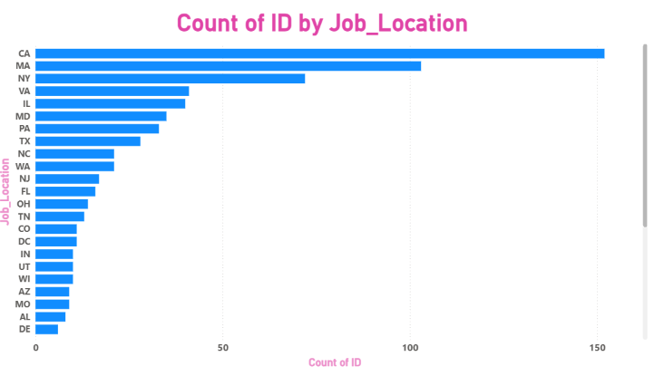

Figure 1. Top 15 states by number of job postings.

2. Average Minimum & Maximum Salary by State
Among the ten states with the most job postings, California and Illinois post both the highest minimum and highest maximum salary ranges, while Pennsylvania and Texas trend lower on both ends.
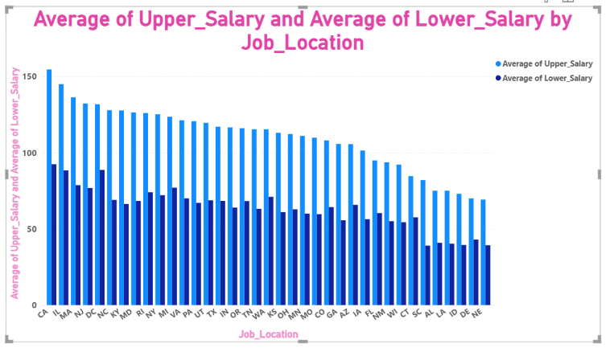
Figure 2. Average minimum and maximum posted salary by state (top 10 states by job count).

3. Average Salary by State
Looking at average salary (midpoint of posted range) across all states, California leads at $123.5K, followed by Illinois ($116.7K) and Washington DC ($110.2K). At the other end, several lower-volume states such as Nebraska, Idaho, and Delaware average under $60K — though these are based on very few postings each and should be read with caution.
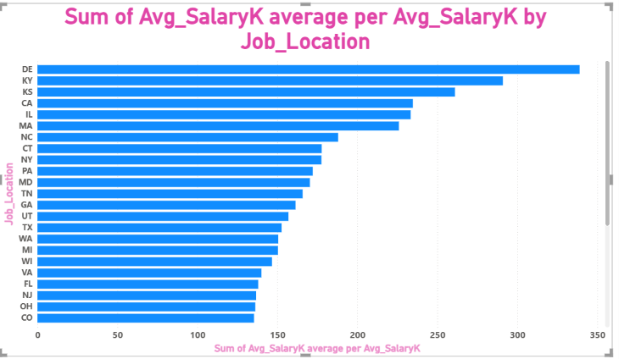
Figure 3. Top 15 states by average salary ($K).

4. Top 5 Industries with the Most Data Science Job Postings

Biotech & Pharmaceuticals is by far the largest hiring industry for data science roles, nearly double the next closest industry. This reflects heavy investment in data-driven drug discovery, clinical trial analytics, and genomics.
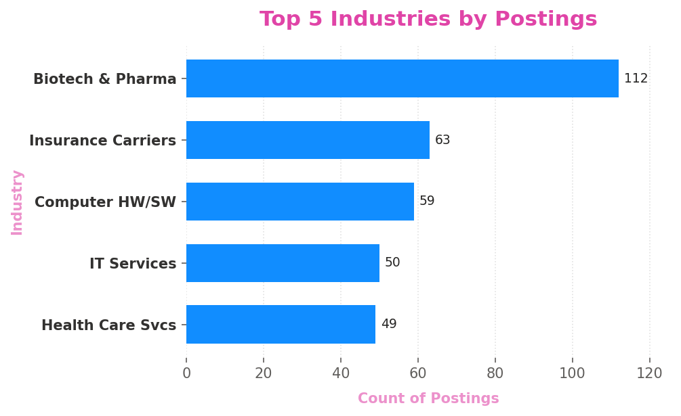
Figure 4. Top 5 industries by number of data science job postings.
Rank | Industry | Postings
1 | Biotech & Pharmaceuticals | 112
2 | Insurance Carriers | 63
3 | Computer Hardware & Software | 59
4 | IT Services | 50
5 | Health Care Services & Hospitals | 49

5. Companies with the Most Job Openings
Hiring is fairly fragmented — no single company dominates. Takeda Pharmaceuticals, MassMutual, and Reynolds American each post 14 openings, the most of any employer in the dataset, reinforcing the strength of pharma and insurance as top hiring sectors.
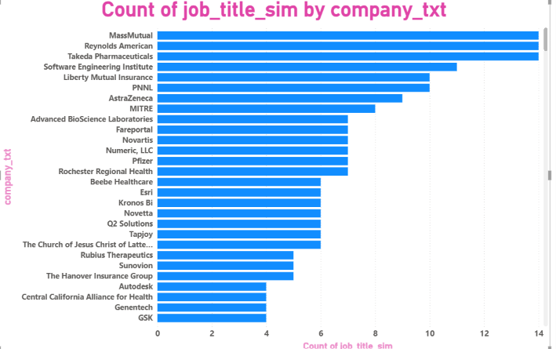
Figure 5. Top 10 companies by number of job postings.

6. Job Titles with the Most Number of Jobs

'Data Scientist' is the single largest job title category (313 postings, 42% of the dataset), followed by a broad 'other scientist' bucket and 'Data Engineer'. Pure 'Analyst' roles are also common (101 postings).

. 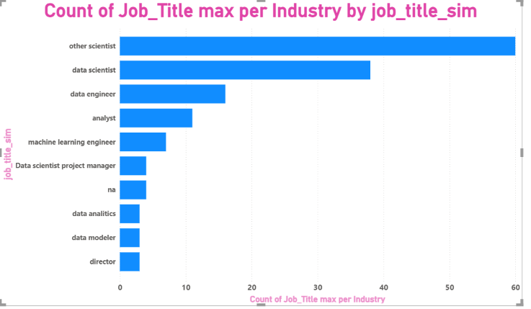

Figure 6. Number of job postings by job title category

Salary by Job Title
Despite being less common, 'Director' and 'Machine Learning Engineer' roles command the highest average salaries ($130.8K and $126.4K respectively), while general 'Analyst' roles pay the least on average ($66.1K). 'Data Scientist' — the most common title — pays solidly above the dataset average at $118.3K.
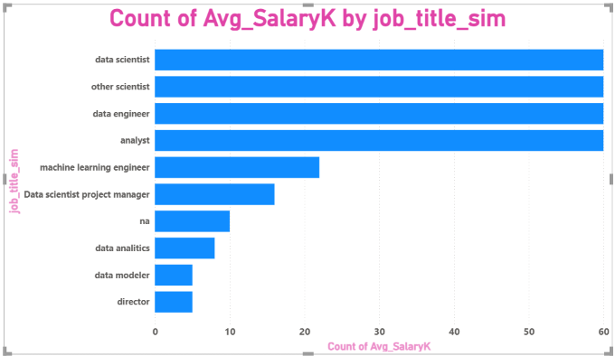
Figure 7. Average salary by job title category ($K).

7. Skills Required by Companies for Each Job Title
Skill requirements vary meaningfully by role. Python is near-universal for Data Scientists (77%) and especially Machine Learning Engineers (82%), while Data Engineers stand out for Spark (56%), AWS (50%), and Hadoop (42%) — reflecting their focus on data infrastructure over modeling. Analysts lean more heavily on Excel (76%), SQL (74%), and Tableau (40%), consistent with a reporting-and-dashboards focus rather than machine learning.
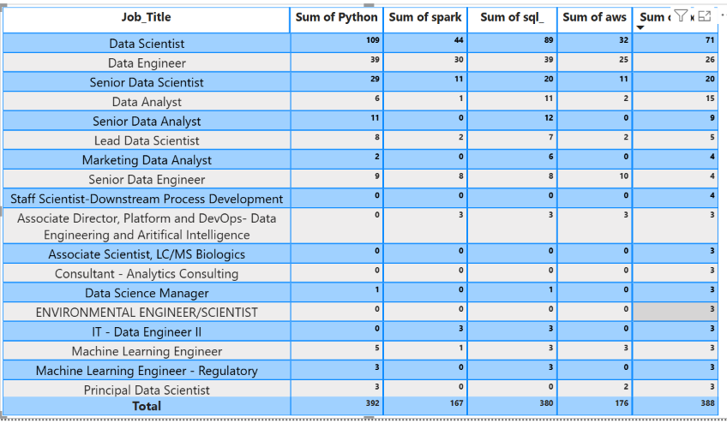
Figure 8. Share of postings requiring each skill, broken down by job title.
Across all postings regardless of title, the three most universally requested skills are Python (53%), Excel (52%), and SQL (51%). Deep learning frameworks (Keras 4%, PyTorch 5%) and niche big-data tools (Flink 1%, Google Analytics 2%) are comparatively rare, suggesting they are valuable specializations rather than baseline requirements.
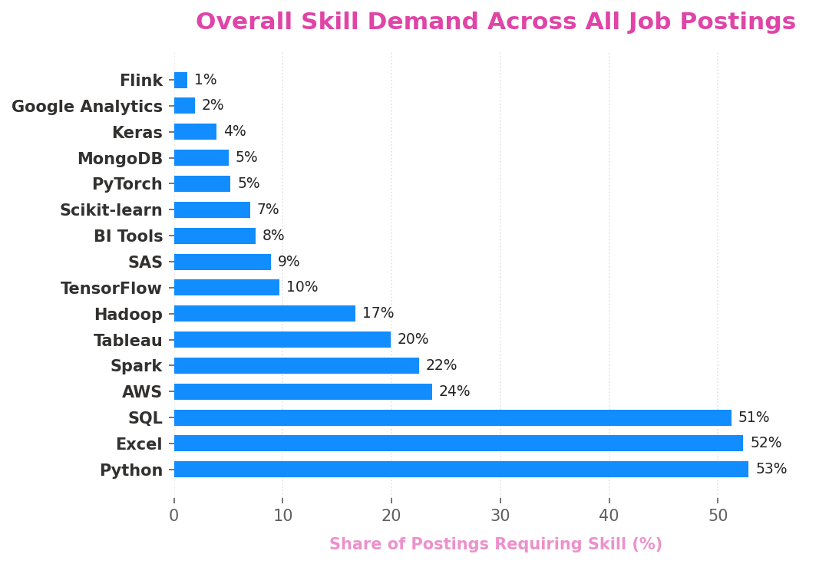
Figure 9. Overall skill demand across all 742 job postings.

8. Relationship Between Average Salary and Education

There is a clear, consistent relationship between the education level a posting calls for and its salary: roles that mention a preference for a PhD pay the most on average ($116.0K), followed by master's-preferred roles ($105.6K), with roles that don't mention an advanced degree averaging noticeably less ($94.7K). Postings without a stated degree preference are also the most common (383 of 742), suggesting many employers are flexible on formal education if the right skill set is present.
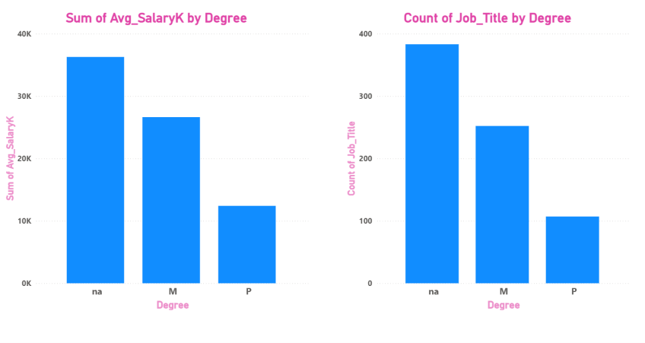
Figure 10. Average salary and posting volume by education requirement.
A similar pattern holds for seniority: postings explicitly labeled 'senior' in the title average $121.7K versus $93.1K for postings with no seniority indicator in the title, and just 3 postings were explicitly labeled 'junior' in this dataset (averaging $71K) — junior-level roles are likely underrepresented because entry-level postings less often spell out seniority in the title.

9. Additional Insights

Company Size & Ownership
Average salary does not increase steadily with company size — the relationship is closer to a U-shape, with the smallest companies (1-50 employees, $105K) and the very largest (10,000+, $112.8K) both paying above mid-sized companies (501-1,000 employees, $91.5K). Publicly traded companies pay the most on average ($111.0K), while hospitals ($66.8K) and nonprofit organizations ($73.2K) pay the least — likely reflecting differences in budget structure and revenue models between the public and social sectors.
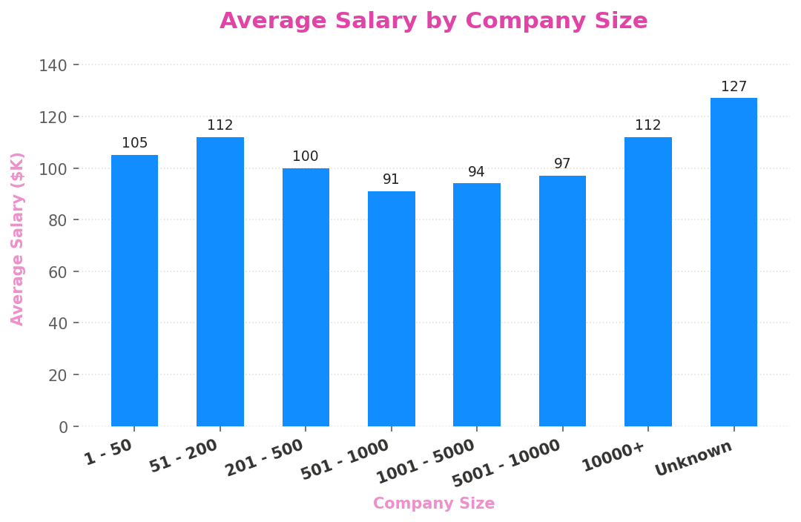
Figure 11. Average salary by company size.
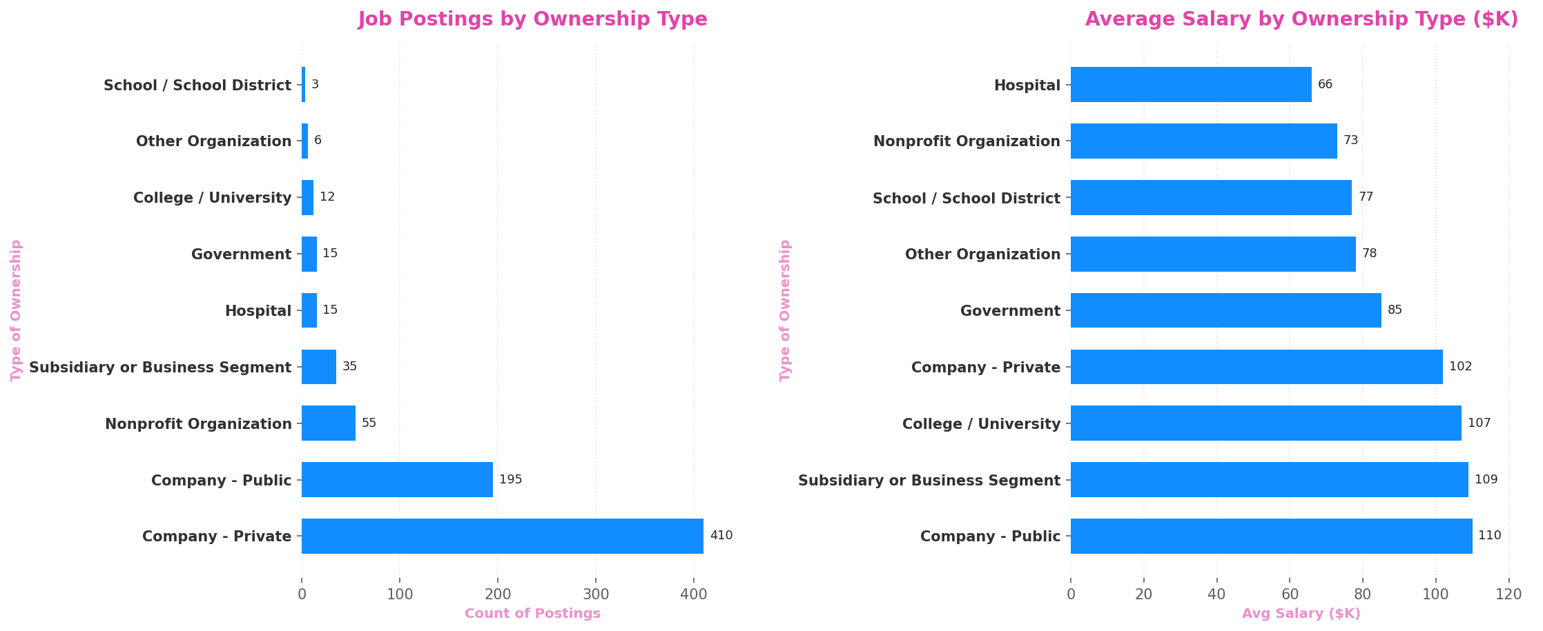

Figure 12. Job posting volume and average salary by ownership type.

Sector Analysis
Information Technology is the largest hiring sector overall (180 postings) once individual industries are rolled up, followed by Biotech & Pharmaceuticals (112) and Business Services (97). Information Technology also pays the most among high-volume sectors ($113.2K), narrowly ahead of Biotech & Pharmaceuticals ($112.1K); Health Care trails noticeably at $77.1K despite strong hiring volume.
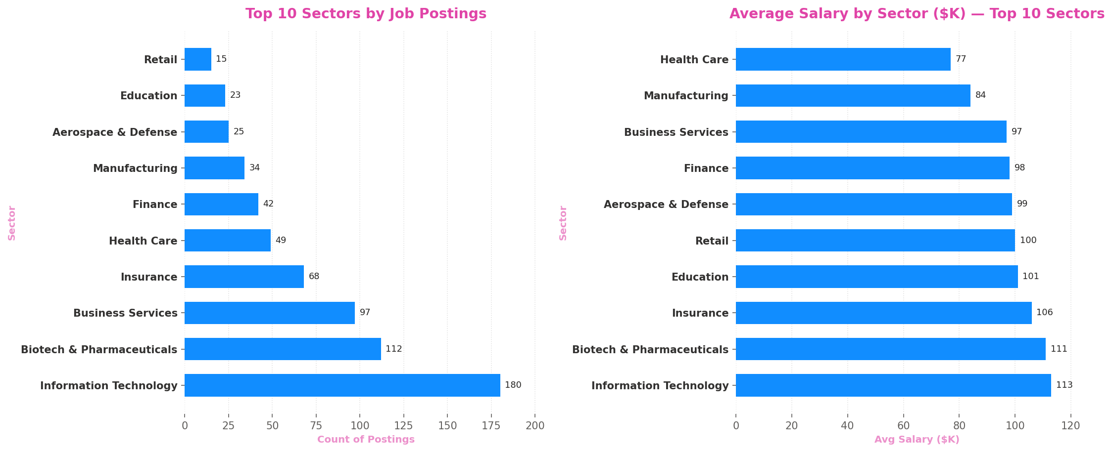
Figure 13. Job posting volume and average salary by sector (top 10 sectors).
Company Rating vs. Salary

Company ratings (out of 5, from Glassdoor reviews) are only weakly correlated with average salary (correlation coefficient ≈ 0.13). This suggests that a higher-paying job is not a strong predictor of employee satisfaction — culture, management, and work-life balance likely matter as much or more than compensation in how employees rate their employer.
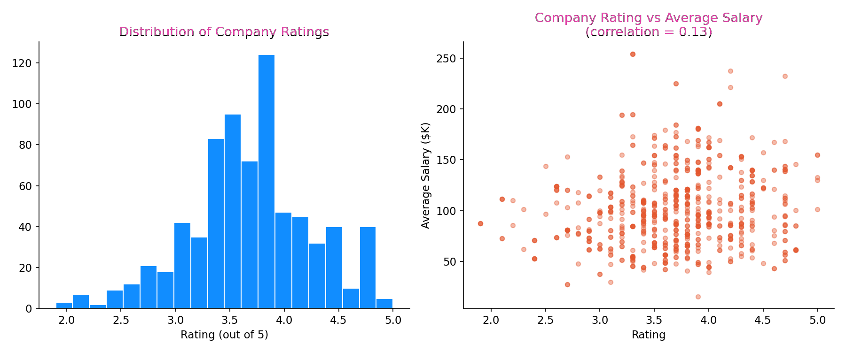
Figure 14. Distribution of company ratings, and their relationship to average salary.

Over all Salary Distribution
The distribution of average salaries is right-skewed, with most postings clustered between $60K and $130K and a long tail of high-paying roles above $150K (mainly senior, PhD-preferred, and ML engineering positions). Only 24 of 742 postings (3.2%) report an hourly rather than annual rate, and just 17 postings (2.3%) had employer-provided salary data rather than a Glassdoor estimate.
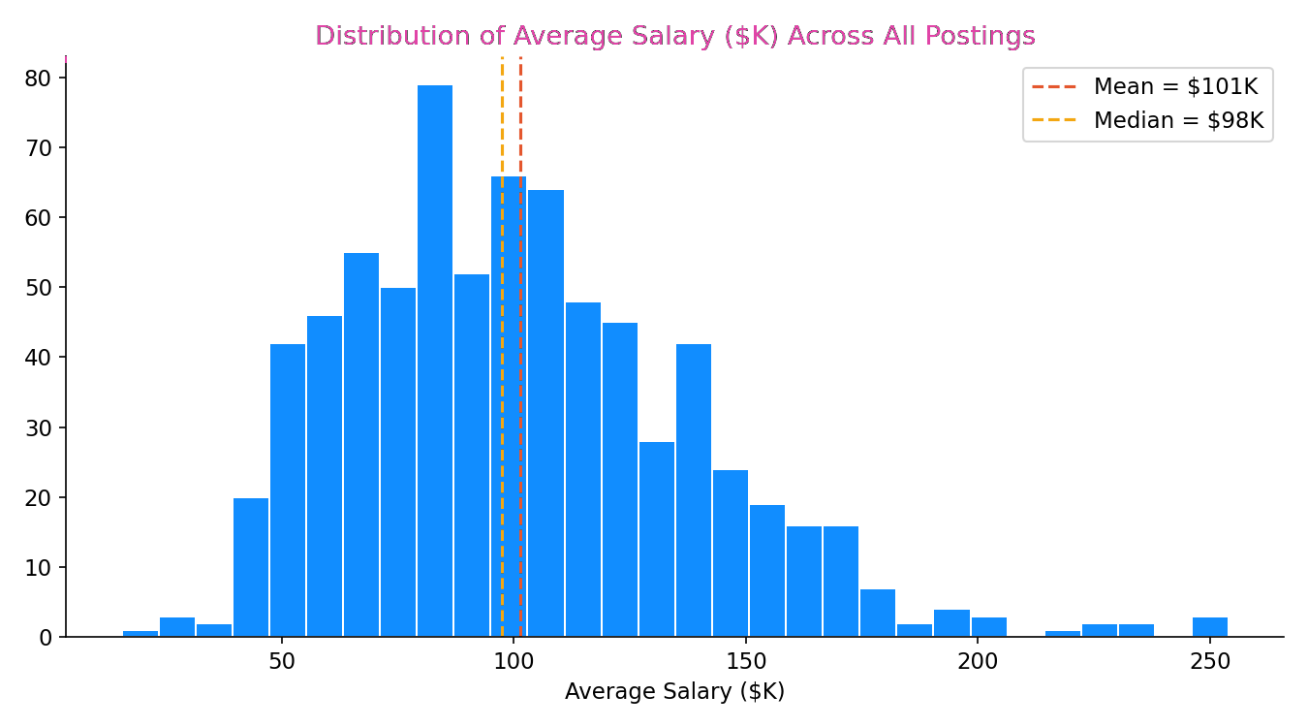
Figure 15. Distribution of average salary across all postings.

10. Insights & Recommendations

For Job Seekers
- Prioritize Python, SQL, and Excel — these three skills appear in roughly half of all postings and form the practical baseline for most data science roles, regardless of specialization.
- If targeting Machine Learning Engineer or Data Scientist roles specifically, invest in deep learning frameworks (TensorFlow, PyTorch, Keras) and strong Python fluency — these roles pay the most and require the most specialized skill sets.
- Aiming for a Data Engineer path pays off in infrastructure skills: Spark, AWS, and Hadoop are the differentiators there, not deep learning libraries.
- An advanced degree (master's or PhD) correlates with meaningfully higher pay — worth factoring into career-investment decisions, though it's not a strict requirement for most postings.
- Geographic flexibility matters: California, Massachusetts, and New York offer both the most opportunities and (in California's case) the highest average pay, but competition and cost of living are also highest there.

For Employers
- Benchmark salary offers against title and location together, not in isolation — a 'Data Scientist' posting in California should be priced very differently than the same title in a lower-cost state.
- Since company rating correlates only weakly with salary, employers competing for talent on a budget should invest in culture, management quality, and career growth rather than assuming pay alone drives satisfaction.
- For companies outside biotech/pharma and IT, expect to compete harder for the same skill sets (Python, SQL) that dominate demand — consider clearer articulation of non-salary differentiators in postings.
- Standardize how seniority and degree preference are stated in job titles/descriptions — the data show these fields are inconsistently reported, which can undercut a company's ability to attract the right-level candidates.

For Ongoing Monitoring
The accompanying dashboard (Tableau/Power BI) should be refreshed as new postings are scraped so that salary benchmarks, skill demand, and top hiring companies/industries stay current — this is a fast-moving market and skill demand (e.g., for newer tools) can shift within a single hiring cycle.

11. Conclusion
This analysis of 742 U.S. data science job postings shows a market concentrated in a small number of states and industries — led by California and the Biotech/Pharma sector — but with consistent skill demand nationally around Python, SQL, and Excel. Pay scales predictably with seniority and education level, and role type (Data Scientist vs. Engineer vs. Analyst) is the strongest driver of which specific skills matter most. Job seekers should tailor their skill investments to their target title, while employers should benchmark compensation by location and title jointly and look beyond salary to compete for talent.

